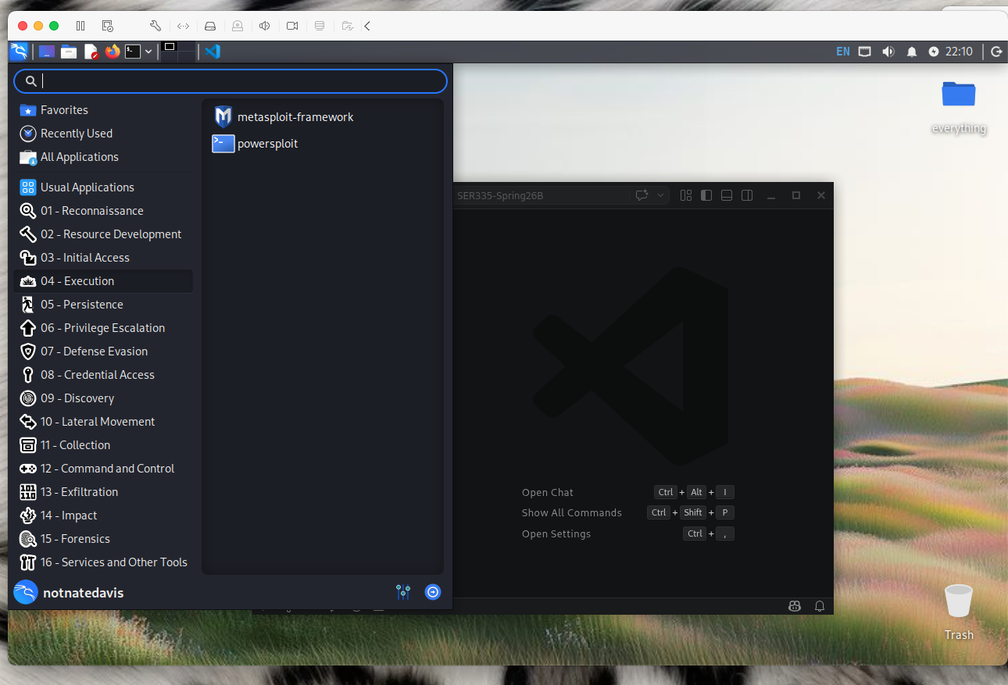
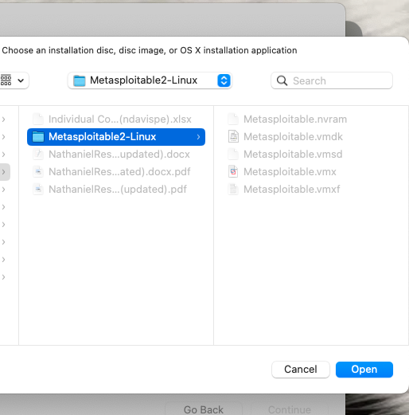
  - Metasplitable2-Linux
  - Metasplitable2-Linux
  - Metasplitable2-Linux
  - sudo adduser ser335hacker
- X

